* Assets > controllers > home_controller.rb

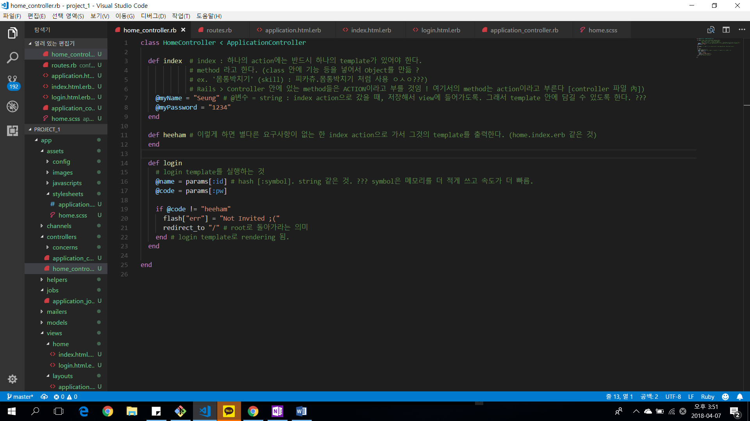

* Application.html.erb

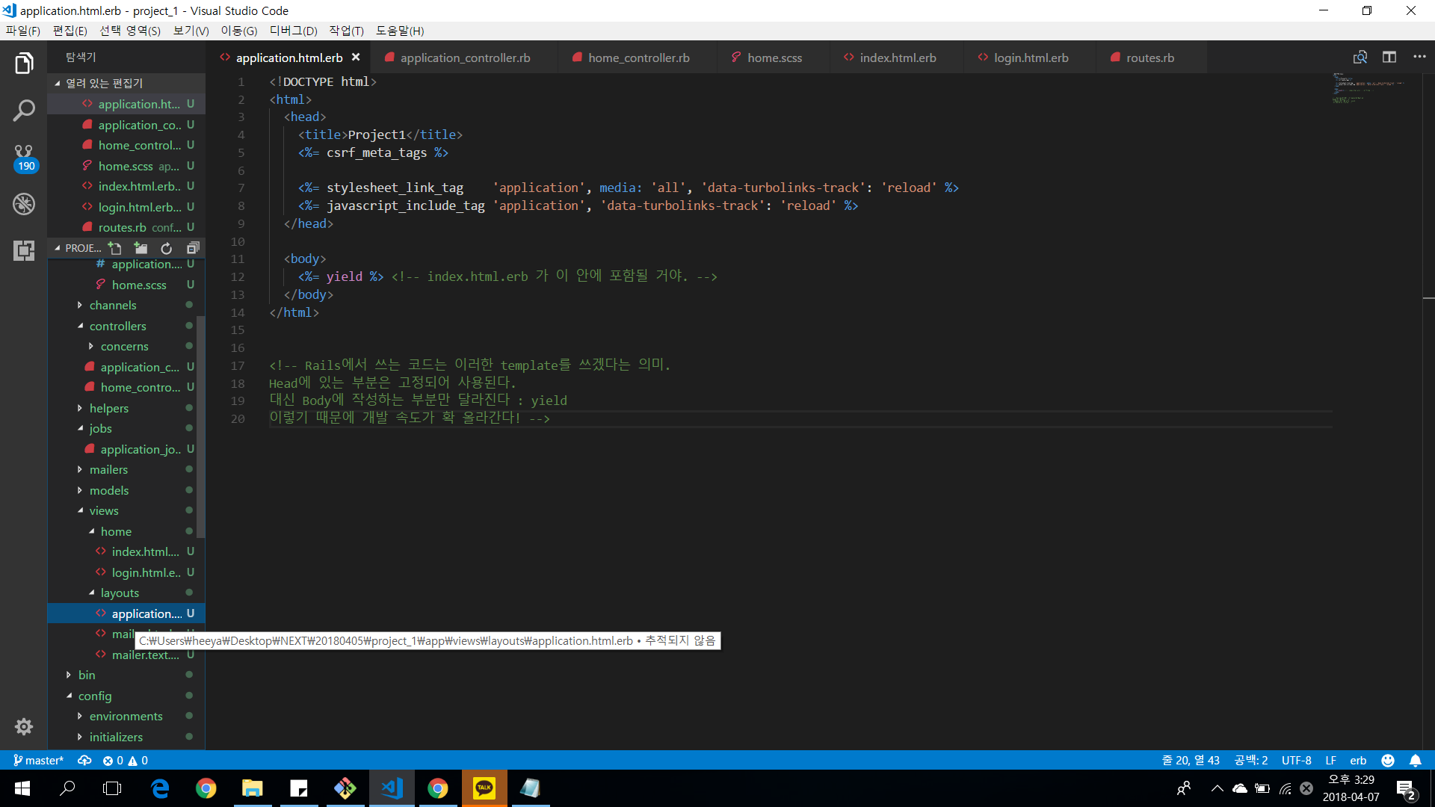

* Config > routes.rb

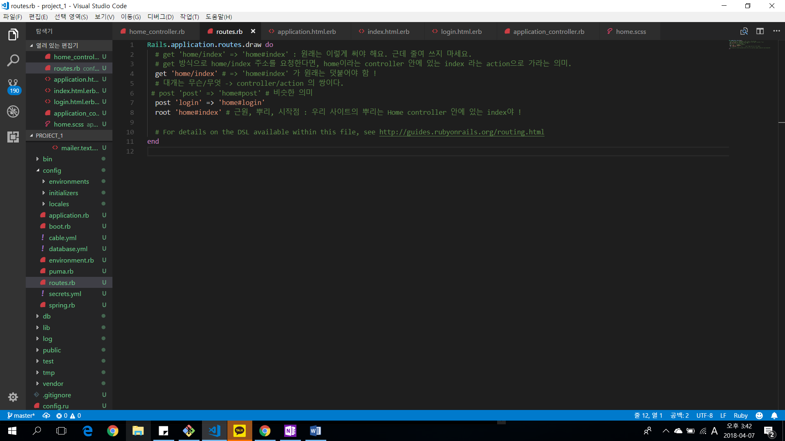

* Assets > views > layouts > application.html.erb

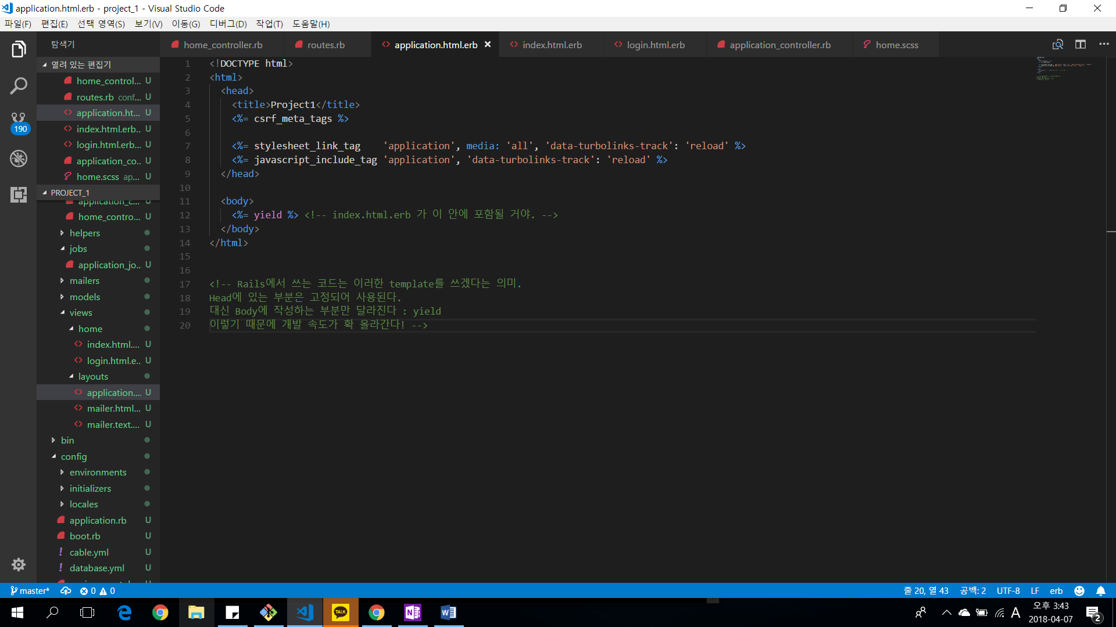

* Assets > views > home > index.html.erb

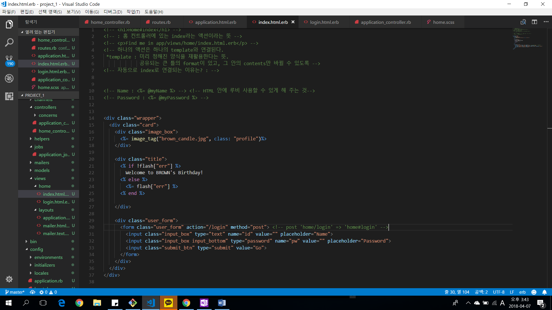

* Assets > views > home > login.html.erb

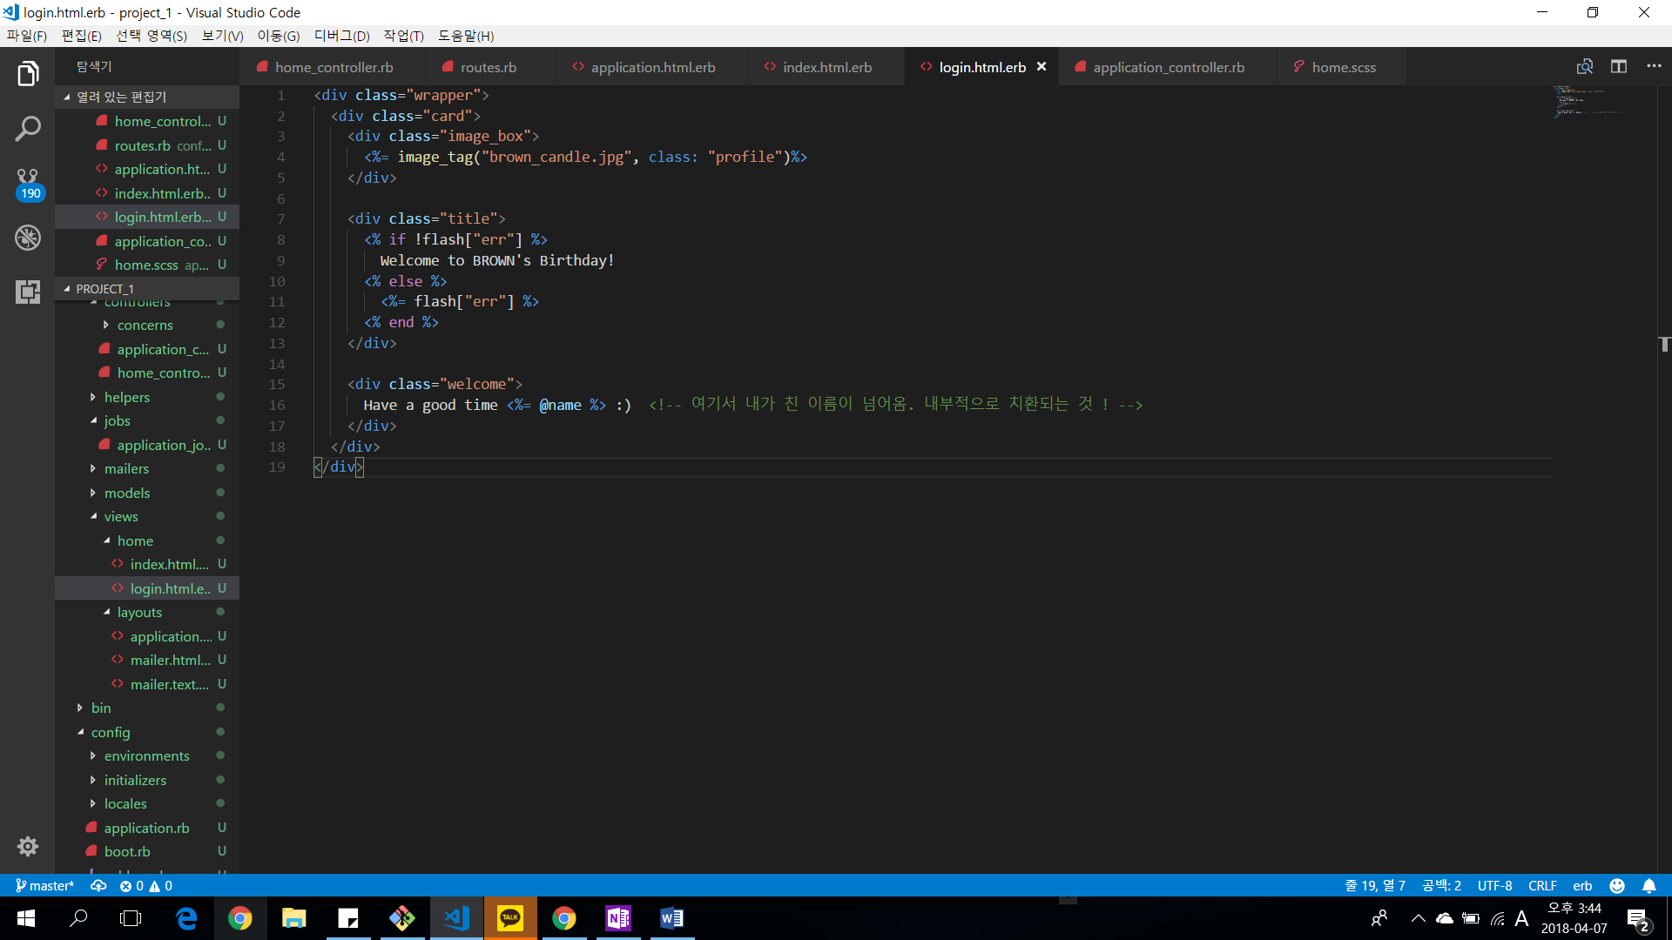

* Assets > app > controllers > concerns > application_controller.rb

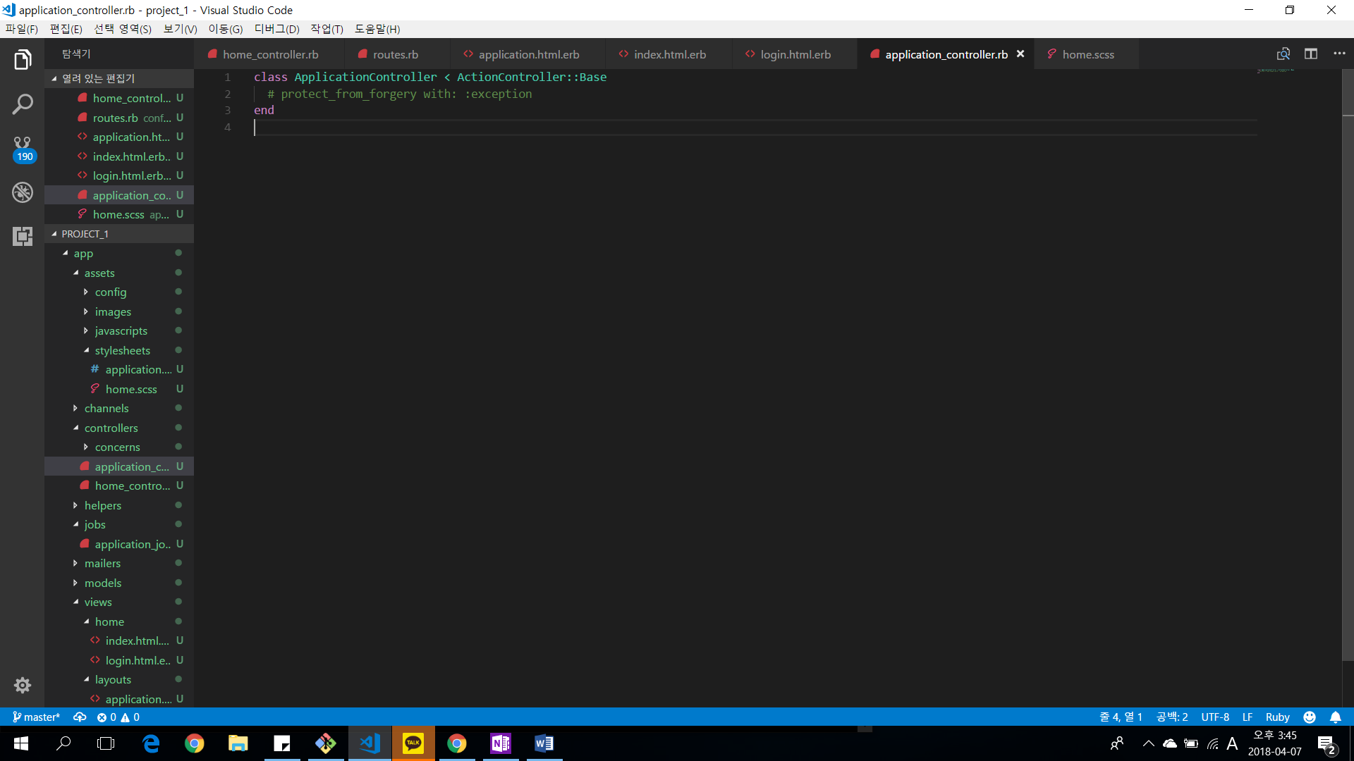

* App > assets > stylesheets > home.scss

